Things can be stored in local storage and session storage in browser
Local storage: can be stored update 5MB data and it persists until cleared manually/programmatically
Session storage: available only for current session if session expires or browser closes data is deleted.

// set local storage items. Data is stored as key value.
// below two examples create two keys and values
localStorage.setItem('name', 'Ashpak');
localStorage.setItem('age', '34');

// set session storage item
sessionStorage.setItem('name', 'Mulani');

// remove data stored with key 'age' from storage
localStorage.removeItem('age');

// read data from local storage
const name = localStorage.getItem('name');

// clear local storage
localStorage.clear();

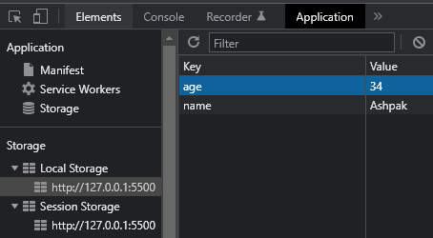

Rather than only storing single text item as value we can store arrays, JSON objects in storage.
** Local storage only store data in text format, so we need to convert data in text format using JSON.parse() before storing in storage and after reading back we need to again convert to original format using JSON.stringify()

Here is example how to store and retrieve tasks list in storage, so that even if browser is closed and reopened tasks list will be retrieved persistently.

let frmTask = document.getElementById('task-form');
// add event handler to form for submit action
frmTask.addEventListener("submit",handleSubmit);

function handleSubmit(e){

let tasks = [];
//tast textbox element
let taskItem = document.getElementById('task')

if(localStorage.getItem('Tasks') === null){
tasks.push(taskItem.value);
// local storage stores data only in string format so we need to
// stringify data beforeadding
localStorage.setItem('Tasks',JSON.stringify(tasks));
}
else{
// after reading string datafrmo local torage parse it to its
// original form, in this case array
tasks = JSON.parse(localStorage.getItem('Tasks'));

// add new tasks item at the end of array filled with existing tasks
// from local storage data
tasks.push(taskItem.value);

// add updated data to local storage
localStorage.setItem('Tasks',JSON.stringify(tasks));

}
alert("Task Updated");
e.preventDefault();
}

